1.

Files of the JCF website on GitHub. It can be downloaded. You can see the functional and working website [here](https://eigoganbare.github.io/mini-projects/JCF/index.html). https://eigoganbare.github.io/mini-projects/JCF/index.html

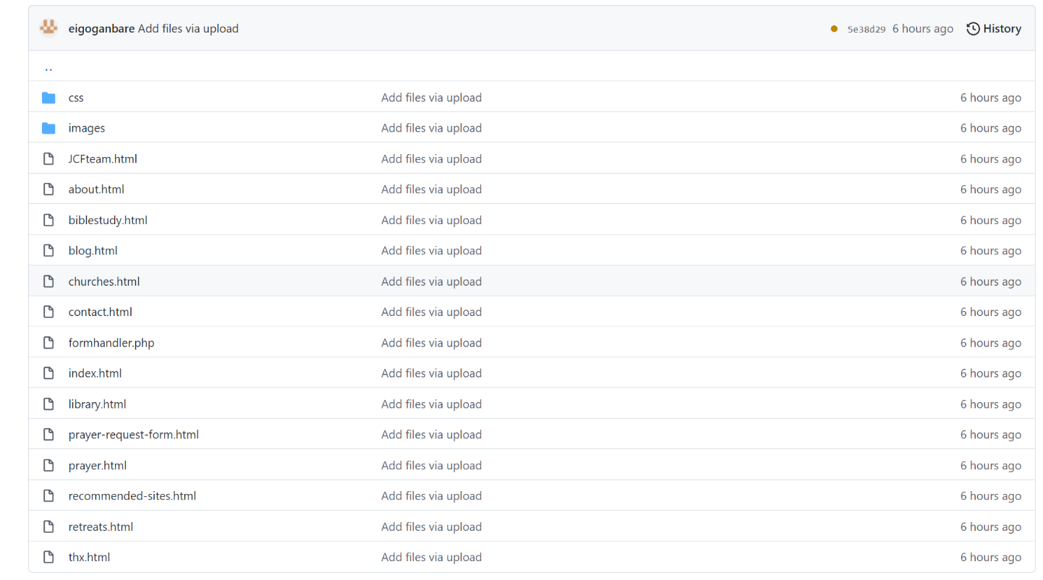

2.

All images are stored in the “images” folder.

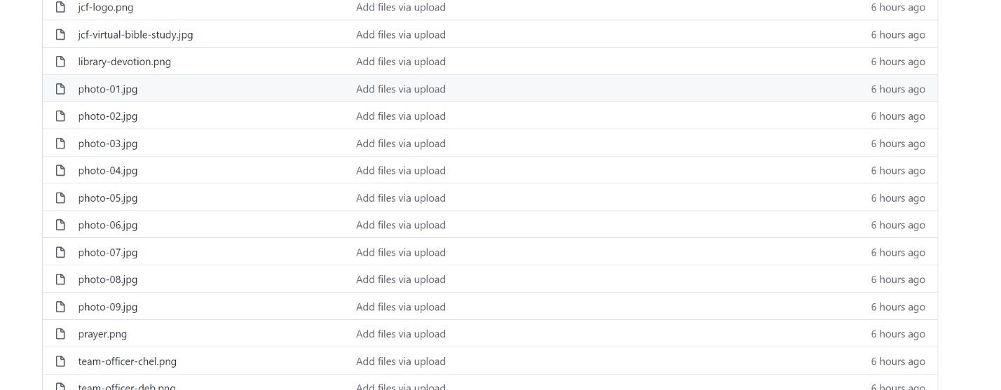

3. How to change text on any .html files:

For example, if you see <p> </p>, you can edit what you need in between.

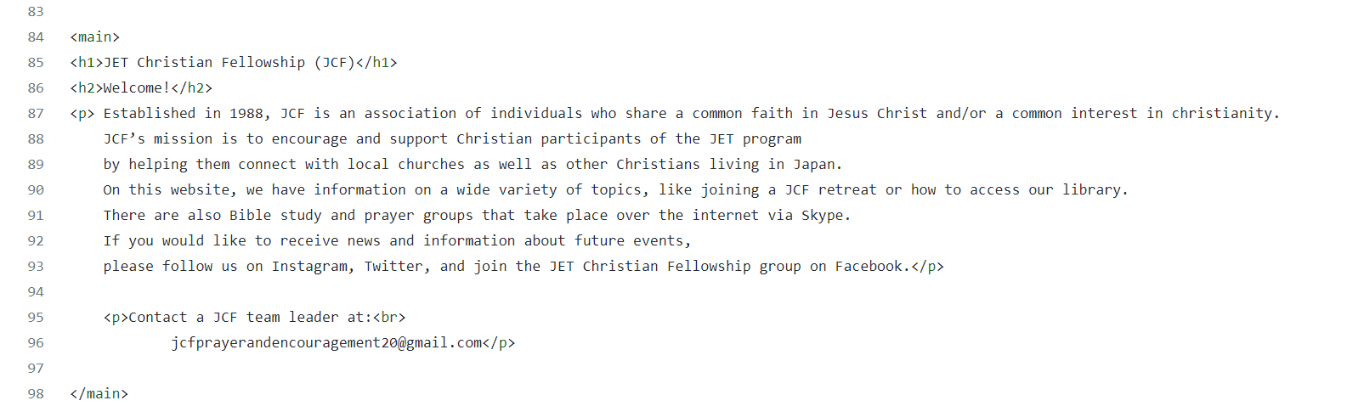

4. How to change photos:

For example, put some photos into the “images” folder. Then, edit the .jpg or .png file.

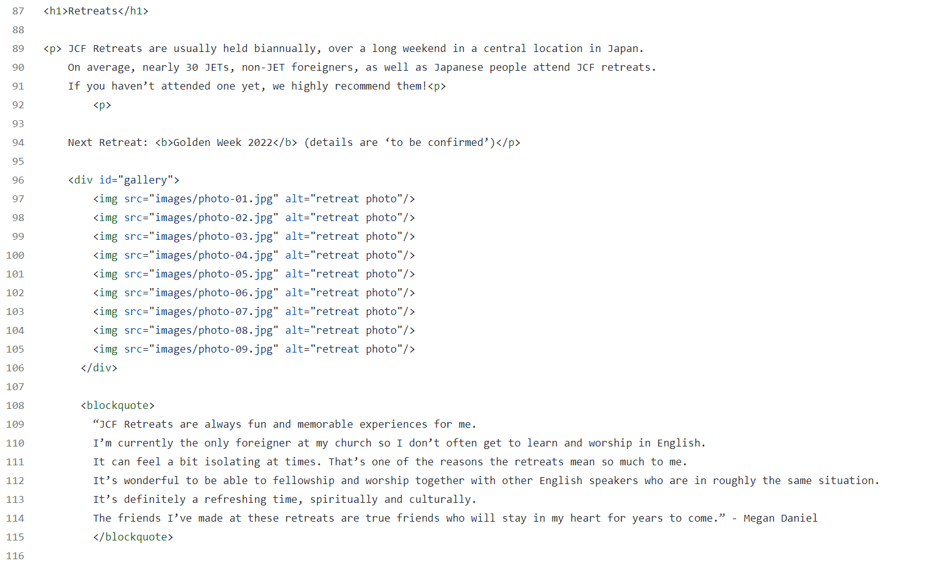

Sidenote! WordPress is a nice software for complex websites and that merit of it. It makes it somewhat easy, but the downside is that you still have to learn it once more, and is a learning curve when you change the theme of JCF or upgrade WordPress some years later. The old-school way without WordPress is very light and if the website is simple, then not so complicated at all.